- :

***Empowering women in the environmental field through education, encouragement, outreach and networking.***

# Thursday, January 26th, 2023 – 11:30am-1:30pm Location: UER Conference Room

**505 Airline Drive, Coppell, TX 75019**

**WE – January Board Meeting**

Zoom Link: [https://us 06web.zoom.us/j/87099642617? pwd=TFR5ZEJkK21rUGdEYWNRaDdoVUFRUT09](https://us06web.zoom.us/j/87099642617?pwd=TFR5ZEJkK21rUGdEYWNRaDdoVUFRUT09)

* Call to Order – Terry Shultz

Passcode: 836519

* Confirming the 2023 Board – Terry Shultz & Linda Pavlik
  + Removing: Olinka Green, Patricia Redfern
    - Jaime Vineyard stepping down as Secretary
      * Need to replace
  + Remaining: Melinda Rushing, Samantha Reynolds, Pharr Andrews, Amelia Hudson, Terry Shultz, Linda Pavlik, Faye Davis
  + Linda Pavlik will be acting President
  + Motion to approve passed
* Hiring a part time Director and a Marketing/Creative support person/company.
  + Article III, Section 1, Point F 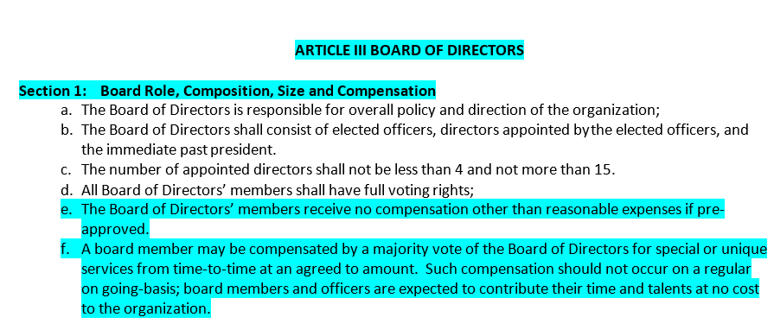
    - Terry can serve as a part-time director
      * Linda will make donations to WE ($225) to pay out to Terry for her services (11 months – February until the end of the year)
      * Motion to approve – Melinda Rushing, Pharr Andrews seconded
        + Vote passed unanimously
* Review of the Interest Survey – Linda Pavlik
  + Linda will send out in a formal form of the results
  + A couple of respondents reached out about making connections and collaborating
* Marketing & Media
  + Need to update Website, switch out photos
  + Hire help with creative ideas and marketing?
    - Need to look at costs
    - 1st send email to all of members looking for pictures
    - Designate a photographer for each event
    - Possibly employ interns from Dallas College
  + Add news page to site?
* Events for 2023
  + February 16, WE Update & Networking
  + March - Suggested: DEI “Diversity, Equity & Inclusion” – this spring at TWU, Alana Taylor and Amurta Saklker
  + April, Oncor
    - Looking at April 13
    - Panel of different career paths
    - Tour of facility
  + April (Earth Week) – EarthX Booth or activity/panel?
    - Booth could be too tedious
    - Ideas for food deserts: Organic farming, Bonton Farms
    - Irving environmental job fair
  + May - Champion Waste – New organic facility, Melinda Rushing
  + Amelia hosting event in June?
  + Faye can host an event at Dallas College in July
  + Pharr – City of Dallas is going to adopt and urban agriculture plan by late summer or early fall
  + Michael Bell from Dallas Half Acre Farms
  + Linda’s husband talk about landfill management
* Membership Recruiting 2023 – Melinda Rushing & Terry Shultz
  + 2023 Membership link is up on website
  + Faye can send communications out tomorrow
  + Send video link during Women’s history month
* Wrap Up – Open Discussion
  + Board continue to meet once a month
    - 2nd Wednesdays, 8:30 AM at Dallas College campus
    - Terry will send invitations
    - February 8 at Farmers Branch Dallas College campus
  + Champion Waste also has a conference room in South Dallas