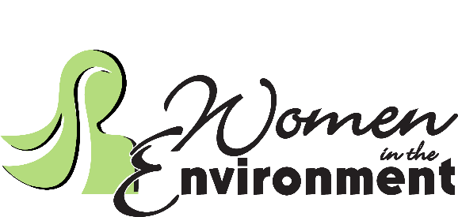

WE Board Meeting:
Wednesday, May 8, 2024 – 8:30 am - 10:00 am
Location: Virtual Meeting

- Call to Order —Linda @ 8:30 AM
  - The following were present: Savannah, Melinda, Kelly, Linda, Sabrina, Amelia
- The minutes from last month were reviewed and approved
- Treasurer’s Report —Samantha Bank Balance: 5741.29, PayPal Balance: 691.20
- Website and Social Media —Kelly
- Board Nominations —Linda
  - Possibly City of Irving, Savannah will check
- 2024 Events
- Oak Cliff Earth Day Recap
- Annual Meeting (Oct -Nov?) —Linda
  - We filed our 990, yearly tax statement
- Gathering Locations —Amelia Thursday evening gathering
  - True Food Kitchen
  - Whiskey Cake
- Water Workshop with co-sponsor —Linda
- Opportunities to Co-Sponsor other environmental-focused activities
- Upcoming Event Dates:
- May 20 – GoodFriends Lunch and Learn Q2_Goodwill (Invite from Goodwill)
- June 10 – Dallas Zoo —Savannah
- August – Perot Museum Thursdays on Tap
- TBD: Kayaking (Kelly will look into this when sites are open) mid-september
- September 10 – Parkland Hospital Sustainability Program —Linda
- October –?
- November –?
- December –?

- Next Meeting – June 12th 8 or 8:30, LaMadeline in Arlington, can set up virtual meeting for anyone who can’t make it.
- Wrap Up —Open Discussion
- Adjourn

